CONTROL STATEMENTS

Every C program consists of set of statements. Every Statement in ‘C’ generally contains expressions and end with a semi-colon. The two most commonly used statements in any programming language are as follows.

- Sequential statements: - These are the statements which are executed one by one.

- Control statements: - These are the statements that are executed randomly and repeatedly.

28) Explain different Control Structures in ‘c’ with example.(very important)

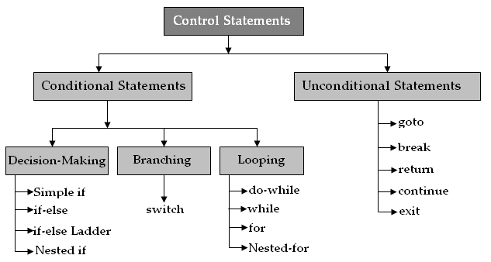
Control Structures:

Control structures are used to change the flow of execution program. Default flow of execution program is sequential.

Generally In Low level languages statements flow is sequential. If we want to execute the statements another time we must define the code another time that means redundancy will occur. Program size is increases. To solve this redundancy in high level languages introduced Control Structures. Using this structures we can execute the group of statements no. of times without writing the code another time.

They are:

1)Conditional Control Statements

2)Un Conditional Control Statements

1) Conditional Control Statements:

The Conditional Control statements are used to change the sequence of program execution based on condition. There are three types of conditional control statements.

- Decision Making statements
- Branching statements
- Looping statements

i) Decision Making statements:

The decision making statements checks the given condition and then executes its block. The decision statement decides the statement to be executed after the success or failure of a given condition. The conditional statements use relational operators. The relational operators are useful for comparing the two values.

a)IF STATEMENT:

C uses the keyword ‘if’ to execute a set of lines or one line when the condition is true. The ‘if’ statement is is used to control the flow of execution of statements.

‘If’ statement can be classified into 4 types.

- Simple if statement
- if…else statement
- nested-if statement
- else-if (ladder) statement.

Simple-if statement:

In this the statement is executed only when the given condition is true. In case the condition is false the compiler skips the lines within the if block.

Syntax:

if (condition)
{
Statement1;
}
Statement_x;

Flow-chart:
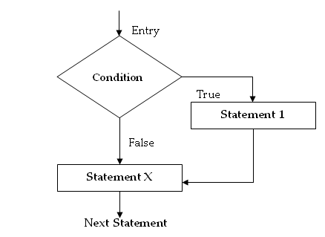

/**********************************************************

w.a.p to check whether the given number is even or odd

**********************************************************/

#include<stdio.h>
#include<conio.h>

void main()
{
int num, a;

clrscr();

printf("\n enter any number....");
scanf("%d",&num);

a = num % 2;

if( a == 0 )
{
printf("\n Given number is even...");
return;
}

printf("\n Given number is odd...");

getch();
}

OUT PUT:

enter any number.....8
Given number is even...

enter any number.... 9
Given number is odd....

If-Else Statement:

An ‘if’ statement with ‘else’ is called as if-else statement. If the condition is true, true block statements are executed. If the condition is false, else block statements are executed.

Syntax:

if (Condition)
{
True Statement;
}
else
{
else statement;
}

Statement_X;

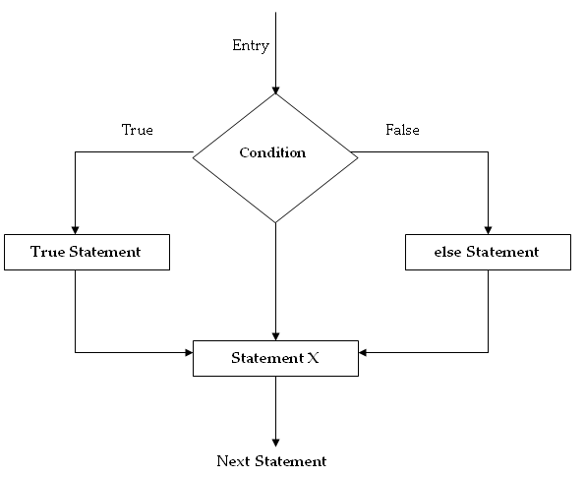
Flow-chart:

/**********************************************************

w.a.p to check whether the given year is leap or not

**********************************************************/

#include<stdio.h>
#include<conio.h>

void main()
{
int year;

clrscr();

printf("\n enter any year");
scanf("%d",&year);

if( year%4 == 0 )
printf("\n %d is a Leap Year...",year);
else
printf("\n %d is not a Leap Year....",year);
getch();
}

OUT PUT:
enter any year...2008
2008 is a Leap Year...

enter any year...2009
2009 is not a Leap Year...

Nested-if Statement:
An ‘if’ statement which contains another ‘if’ statement is called as nested if.

Syntax:

if (Condition1)
{
if (Conditon2)
Statement 1;
else
Statement 2;
}
else
{
Statement 3;
}
Statement X;

Flow-chart:

Entry
Condition1
Statement1
Statement2
Statement3
True False

Condition-2

true True False

Next Statement

/******************************************************** Program to display biggest number from given three numbers using Nested if
********************************************************/
#include<stdio.h>
#include<conio.h>

void main()
{
int a,b,c;

clrscr();

printf("enter the a,b,c values\n");
scanf("%d%d%d",&a,&b,&c);

if(a>b)
{
if(a>c)
printf("a is big");
else
printf("c is big");
}
else
{
if(b>c)
printf("b is big");
else
intf("c is big");
}
}
OUTPUT -
enter the a,b,c values: 10 20 30
c is big

Else–if (ladder-if):
It is a multi conditional checking statement that checks more than one condition. The statements of the respective matched condition are the executed.
Syntax:
if(Condition 1)
Statement 1;
Else if(Condition 2)
Statement 2;
Else if(Condition 3)
Statement 3;
else
Statement 4;
Statement X;

Flow-chart:
_
Statement2

Statement1
Entry

False True
Condition-1

Condition1

TRUE FALSE
Condition-2

Condition2

TRUE FALSE
Condition-3

Condition3

Statement3

Statement4

Statement_x

/******************************************************** w.a.p to check whether the given character is capital letter or small letter or number or a symbol
********************************************************/
#include<stdio.h>
#include<conio.h>

void main()
{
char ch;
clrscr();
printf("\n enter any character.....");
scanf("%c",&ch);

if(ch>='A' && ch<='Z')
printf("%c is a Capital Letter...",ch);
else if(ch>='a' && ch<='z')
printf("%c is a Small Letter...",ch);
else if(ch>='0' &&ch<='9')
printf("%c is a number.....",ch);
else
printf("%c is a symbol....",ch);
getch();
}

OUTPUT -
enter any character.... G
G is a Capital Letter.....
enter any character.. $
$ is a symbol......

/******************************************************** w.a.p to accept the student id, name, 3 subject marks
And find total, average and grade of the student according to the given marks.
********************************************************/

#include<stdio.h>
#include<conio.h>

void main()
{
int sid;
char sname[20];
int s1, s2, s3;
int total;
float avg;

clrscr();

printf("Enter the student id : ");
scanf("%d",&sid);

printf("Enter the student name : ");
fflush(stdin);
gets(sname);

printf("Enter 3 subject marks : ");
scanf("%d %d %d",&s1,&s2,&s3);

total = s1 + s2 + s3;
avg = total/3;

printf("Student ID: %d\n",sid);
printf("Name : %s\n",sname);
printf("s1=%d, s2=%d, s3=%d\n",s1,s2,s3);
printf("Total = %d\n",total);
printf("Average = %.2f\n",avg);

if( s1>35 && s2>35 && s3>35 )
{
if(avg>=60 )
printf("Grade : First");
else
if( avg>=50 )
printf("Grade : Second");
else
printf("Grade : Third");
}
else
printf("Fail, No Grade");
}

ii) Branching statements:

a)Switch Statement:
Switch statement takes the given expression and execute the block of the given expression. If expression not found then executes default block.

Syntax:

switch( expr )
{

case exp1 :
statement1;
break;
case exp2 :
statement2;
break;

.....
.....

case exp_n :
statements;
break;

default:

default_statements;
}

/**************************************************
W.A.P TO READ THE SINGLE DIGIT NO. AND PRINT
THAT DIGIT INTO WORDS
**************************************************/
#include<stdio.h>
#include<conio.h>

main( )
{
int no;

clrscr();
printf("Enter any number");
scanf(“%d”,&no);

switch( no )
{
case 0:
printf("zero");
break;
case 1:
printf("two");
break;
case 2:
printf("two");
break;
case 3:
printf("three");
break;
case 4:
printf("four");
break;
case 5:
printf("five");
break;
case 6:
printf("six");
break;
case 7:
printf("seven");
break;
case 8:
printf("eight");
break;
case 9:
printf("nine");
break;

default:
printf("invalid single digit");
}
}

iii)Looping statements:

A portion of the program that is executed repeatedly is called a loop. A looping statement can also be called as iterative statement that executes a set of statements repeatedly for the specified number of times based upon the given condition. The C programming language contains three different program statements for program looping.

They are

a)while loop
b)do while loop
c)for loop

a)while Loop:

while loop executes the block no. of times until the condition is false.

Syntax:

initialise_section

while( condition ) {
//statements

Increment/decrement
}

Next_statements

Example:

Int i=1, sum=0;

While( i<=10 )
{

Sum = sum + I;

I = I + 1;

}

Printf(“sum is : %d”,sum);

Flow-chart:

Entry

Initialization

Test Condition

True false

Body of the loop

Next Statement

B)Do..while Loop:

As like while loop do..while also executes the block no. of times until the condition is false. But difference is while loop first checks the condition and execute the statement. So while loop is called entry checking loop. Do..while first executes the block after check the condition. So this is called exit checking loop.

Syntax:

initialise_section

do
{
//statements
Increment/decrement

}while( condition );

Next_statements
Example:

Int i=1, sum=0;

do
{

Sum = sum + I;

I = I + 1;

} While( i<=10 );

Printf(“sum is : %d”,sum);

Flow-chart:

Body of the loop
Test Condition
Initialization

Entry

False true

Next Statement

c)For loop:

‘for’ statement execute the block n number of times until the condition is false. This for loop statement contains 3 parts. First one is initialization section in this section we can define the variables which are used in the block, second one is condition, third one is increment/decrement block

Syntax:

for( intialization; condition; increment/decrement)
{

//statements;
}

Ex:1

int i;

for( i=1; i<=5; i++ ) {
printf(“ %d \t”,i);
}

for( i=5; i>=1; i--) {
printf(“ %d \t”,i);
}

Output:

1 2 3 4 5

5 4 3 2 1

Flow-Chart:

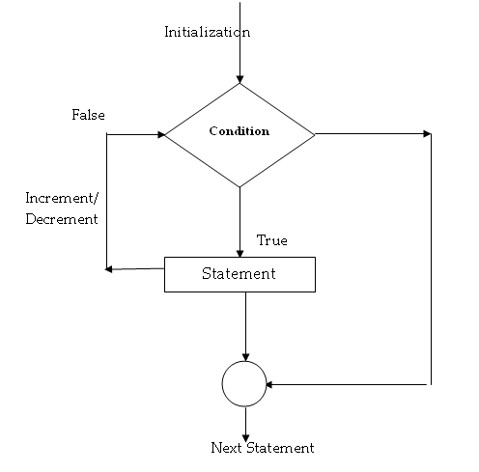

Nested Loops:

A loop which contains another loop is called as nested loops. We can define the while, for loops as nested loops.

Ex:
int i, n;

for( i=1; i<=100; i++)
{
n=i; fact=1;

for(j=1; j<=n; j++)
fact=fact*j;

pf(“%d factorial is %d”,n,fact);
}
2)Unconditional Control Statements:

Unconditional control statements are used to change the sequence of program execution without using any condition. Goto, continue, break, exit, return statement is a unconditional control statements.

a)Goto Statement:
Goto statement is used to execute the specific block.

The goto requires a label in order to execute the specific code. A ‘label’ is any valid variable name, and must be followed by a colon. The label is placed immediately before the statement where the control is to be transferred.
Syntax:

label:
Statements;

goto label;

Forward branching Backward branching
goto label:
…………….
……………
……………
label:
statement;
Label:
statement;
…………….
……………
goto label:

(a) Forward Jump (b) mp

/**********************************************************
w.a.p to check the given no. is even or odd
***********************************************************

#include<stdio.h>
#include<conio.h>
#include<ctype.h>

void main()
{
int no;

read:
clrscr();

printf(“Enter the number “);
scanf(“%d”,&no);

if( no % 2 == 0 )
printf(“Given no is even”);
else
printf(“Given no is odd”);

printf(“Do u want to check another no(y/n):”);
ch = getche();

if(ch==’Y’ )
goto read;

}

b)break:

Terminates the loop in middle of execution

Ex:

/*********************************************************
EXAMPLE FOR BREAK
**********************************************************/

#include<stdio.h>
#include<conio.h>

main()
{

int i=0;

while( i<=10 )
{
i++;

if(i==5 )
break;

printf(“%3d”,i);
}

printf(“while terminated”);
}

Output:
1 2 3 4

While terminated

c)continue:

used to skip the specific iteration of the loop and continue the next iterations

/*********************************************************
EXAMPLE FOR CONTINUE
**********************************************************/

#include<stdio.h>
#include<conio.h>

main()
{
int i;

i = 0;

while( i<=10 )
{
i++;

if(i==5 )
continue;

printf(“%3d”,i);
}
}

Output:
1 2 3 4 6 7 8 9 10

d)exit:

Terminates the application in middle of execution

/*********************************************************
EXAMPLE FOR EXIT
**********************************************************/

#include<stdio.h>
#include<conio.h>
#include<stdlib.h>

main()
{

int i=0;

while( i<=10 )
{
i++;

if(i==5 )
exit(0);

printf(“%3d”,i);
}

printf(“program terminated”);
}

Output:
1 2 3 4

5)return:

Terminates the function in middle of execution

/*********************************************************
EXAMPLE FOR ‘RETURN’
**********************************************************/

#include<stdio.h>
#include<conio.h>
#include<stdlib.h>

main()
{

int i=0;

while( i<=10 )
{
i++;

return;

printf(“%3d”,i);
}

printf(“program terminated”);
}

Output:
1

/*******************LAB_PROGRAM-1**************************
w.a.p for

i) sum of Factors of a number
ii) sum of digits of a number

*********************************************************

#include<stdio.h>
#include<conio.h>

void main()
{
int i, a, no, m, factors_sum=0,digits_sum=0;

clrscr();

printf("Enter the number : ");
scanf("%d",&no);

/******************************
SUM OF FACTORS OF A NUMBER
******************************/

i = 1;

while( i <= no )
{
if( no % i == 0 )
{
factors_sum = factors_sum + i;
}

i++;
}

printf("%d factors sum is : %d\n",no,factors_sum);

/******************************
SUM OF DIGITS OF A NUMBER
******************************/

m = no;

while( no > 0 )
{
a = no % 10;
digits_sum = digits_sum + a;
no = no / 10;

}
printf("%d digits sum is : %d\n",m,digits_sum);

getch();

}

/*******************LAB_PROGRAM-2**************************
Program to check whether a given number is

- Prime number or not
- Perfect number or not
- Armstrong number or not

*********************************************************

#include<stdio.h>
#include<conio.h>
#include<math.h>

void main()
{

int i, a, no, count, sum, m;

clrscr();

printf("Enter the number : ");
scanf("%d",&no);

/***********************************
PRIME OR NOT
***********************************/

count=0;

for( i=1; i<=no; i++ )
{
if( no % i == 0 )
count++;
}

if( count == 2 )
printf("%d is prime\n",no);
else
printf("%d is not a prime\n",no);

getch();

/***********************************
PERFECT OR NOT
***********************************/

sum=0;

for( i=1; i<no; i++ )
{
if( no % i == 0 )
{
sum = sum + i;
}

}

if( sum == no )
printf("%d is perfect\n",no);
else
printf("%d is not a perfect\n",no);

getch();

/***********************************
ARMSTRONG OR NOT
************************************/

sum=0;
m = no;

while( no > 0 )
{
a = no % 10;

sum = sum + pow(a,3);

no = no/10;

}

if( sum == m )
printf("%d is Armstrong",m);
else
printf("%d is not a Armstrong",m);

getch();

}

/******************LAB_PROGRAM-3************************

W.A.P for ROOTS OF A QUADRATIC EQUATION

******************************************************/

#include<stdio.h>
#include<conio.h>
#include<math.h>

void main()
{
int a,b,c,d,e;
float r1, r2;

clrscr();

printf("Enter a,b,c values : ");
scanf("%d%d%d",&a,&b,&c);

d = (b*b)-(4*a*c);

if( d == 0 )
{
r1 = -b/(2*a);
r2 = -b/(2*a);
printf("%f %f roots are real and equal\n",r1,r2);
}

else if( d > 0 )
{
e= sqrt(d);

r1 = (float) (-b+e)/(2*a);
r2 = (float) (-b-e)/(2*a);

printf("%f,%f roots are real and not equal\n",r1,r2);
}
else if( d < 0 )
{
printf("roots are complex and conjugatie %d",d);
}
getch();
}

Exam-Questions:

1)Explain different Control Structures with example

2)What are looping statements in ‘c’? Give Example

3)What is the difference b/w while and do..while

4)Write about various ‘IF’ types in ‘c’.

Exam-Programs:

1)W.a.p to check the given number is Armstrong or not

2)w.a.p to check the given number is palindrome number or not

3)w.a.p to check the given name is palindrom or not

4)W.a.p to display the prime numbers upto 1000

5)w.a.p to print the Fibonacci series upto 500

6)w.a.p to print squares of all odd numbers below 100

/******************************************************

W.A.P for PALINDROM NUMBER

******************************************************/

#include<stdio.h>
#include<conio.h>

void main()
{
int a, no, sum, m;

clrscr();

printf("Enter the number : ");
scanf("%d",&no);

sum=0;
m = no;

while( no > 0 )
{
a = no % 10;

sum = (sum * 10) + a;

no = no/10;

}

if( sum == m )
printf("%d is Palindrom",m);
else
printf("%d is not a Palindrom",m);

getch();

}

/******************************************************

W.A.P for PALINDROM STRING

******************************************************/

#include<stdio.h>
#include<conio.h>
#include<string.h>

void main()
{
char st[80];
int flag=0, len, i;

clrscr();

printf("Enter the name : ");
gets(st);

flag=0;
len = strlen(st)-1;

for( i=0; i<strlen(st)/2; i++, len--)
{
if( st[i]!=st[len])
{
flag=1;
break;

}
}

if( flag !=1 )
printf("%s is palindrom",st);
else
printf("%s is not a palindrom",st);

getch();

}

/******************************************************

W.a.p to display the prime numbers upto 1000

******************************************************/

#include<stdio.h>
#include<conio.h>

void main()
{

int i, no, count;

clrscr();

for( no=1; no<=1000; no++)
{

count=0;

for( i=1; i<=no; i++ )
{
if( no % i == 0 )
count++;
}

if( count == 2 )
printf("%d\t",no);

}
getch();
}

/******************************************************

w.a.p to print the Fibonacci series upto 500

******************************************************/

#include<stdio.h>
#include<conio.h>

void main()
{
int f1, f2, fib, no=500;

clrscr();

f1=0; f2=1;

printf("%3d%3d",f1,f2);

fib = f1 + f2;

while( fib < no )
{
printf("%5d",fib);

f1 = f2;
f2 = fib;

fib = f1 + f2;
}

getch();
}

/******************************************************

w.a.p to print squares of all odd numbers below 100

******************************************************/

#include<stdio.h>
#include<conio.h>

void main()
{
long i;

clrscr();

for( i=1; i<=100; i++)
{
if( i % 2 != 0 )
printf("%ld square is %ld\n",i,(i*i));
}

getch();
}

